AMERICAN UNIVERSITY OF BEIRUT



Faculty of Engineering and Architecture



*Department of Mechanical Engineering*

## MECH-341: Materials Laboratory

## Report 2

## Section-4

## March 11, 2009

### Instructor: Cherbel Seif

### Group members:

**Table of Contents**

1. Objective ........................................................................................p. 3

2. Introduction .....................................................................................p. 4

3. Problem approach............................................................................p. 6

4. Anaylsis and calculations................................................................p. 9

5. Observations ...................................................................................p. 14

6. Conclusion.......................................................................................p.15

7. References........................................................................................p. 16

8. Appendix..........................................................................................p. 17

1. Objective

The purpose of this experiment is to obtain a number of experimental results that are used for the characterization of the mechanical properties and performance of materials. The experimental results are the values of ultimate tensile strength, yield strength, % elongation, fracture strain, and Young's Modulus of the selected metals when subjected to uniaxial tensile loading, etc... The experimental results obtained are then used for the design purposes by selecting the right material for a given design temperature. In addition to compare the various mechanical properties of high carbon steel (experiment2) with low carbon steel (experiment1).

1. Introduction

Materials used in conducting experiment were carbon steel. Usually, carbon steel is broken down in to four classes based on carbon content:

*Mild /low carbon steel*

Mild steel is the most common form of steel as its price is relatively low while it provides material properties that are acceptable for many applications. Low carbon steel contains approximately 0.05–0.15% carbon and mild steel contains 0.16–0.29%carbon, therefore it is neither brittle nor [ductile](http://en.wikipedia.org/wiki/Ductile). Low carbon steels suffer from *yield-point* where the materials have two [yield points](http://en.wikipedia.org/wiki/Yield_point). The first [yield point](http://en.wikipedia.org/wiki/Yield_point) (or upper yield point) is higher than the second and the yield drop dramatically after the upper yield point $.^{[1]}$

The yield point can be determined directly from load-deflection curve of the BCC metals such as steel and iron. This yield point phenomenon is associated with a small amount of interstitial or substitution atoms. For example, low-carbon steels which have small atoms of carbon and nitrogen as impurities. Pinning the dislocations by the solute atoms, the stress will be raised in order to overcome the breaking stress required for pulling of the dislocation line from the solute atoms (upper yield point). If dislocation line is free from the solute atoms, the stress required to move the dislocations then suddenly drops which is associated with the lower yield point. In addition, the yield point effect is affected by the amounts of the solute atoms and is also influenced by the interaction energy between the solute atoms and the dislocations.On the other hand, FCC crystal structure such as aluminum does not show the definite yield point same as BCC structure, but it shows a smooth engineering stress-strain curve $.^{[2]}$

*Higher carbon steels*

Carbon steels which can successfully undergo heat-treatment have carbon content in the range of 0.30–1.70% by weight. Trace impurities of various other [elements](http://en.wikipedia.org/wiki/Chemical_element) can have a significant effect on the quality of the resulting steel. Approximately 0.6–0.99% carbon content.Very strong, used for springs and high-strength wire $.^{[1]}$

Due to the commercial importance of ferrous (Fe-C) materials a great deal of work has been done in relating their tensile properties with microstructure and composition. The tensile properties of annealed steels are controlled by the fracture characteristic of the ferrite and the amount, shape, as well as the distribution of cementite. Moreover, the strength of the ferrite depends on the amount of alloying elements in solid solution and ferrite grain size. The carbon content presence has a strong effect because it controls the amount of cementite present either as pearlite or spherodite $.^{[2]}$ The strength increases and ductility decreases with increasing carbon content because of the increased amount of cementitie in the microstructure as shown in figure 1(a). The proportional limit for a particular type depends on its alloy content, however most types of steel have about the same modulus of elasticity. In general, steel has brittle behavior when it contains a high carbon content, and it is ductile when the carbon content is reduced. At a low temperature materials become harder and more brittle, whereas when temperature rises they become softer and more ductile as shown in figure 1(b) $.^{[3]}$

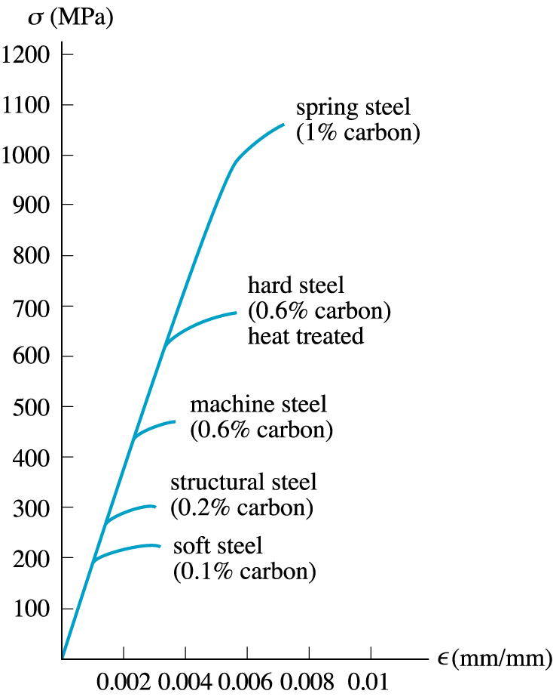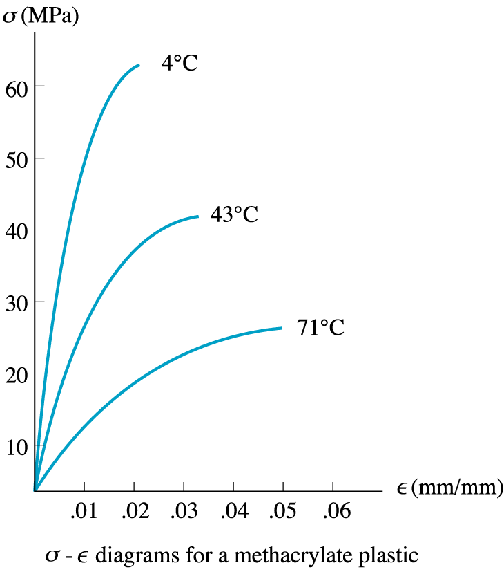

**Figure 1:** *(a) Stress-Strain curves for different carbon composition. (b) Strees-Strain curves of metals at various temperatures $.^{[2]}$*

1. Problem Approach

In this experiment, just like the previous one, our objective is to find out the mechanical properties of the material which are mainly the strength of the material. In scientific words, we want to find out the material’s behavior due to stress, how it deforms, its yield strength, its tensile strength, and its fracture point.

We need to measure the yield strength since it is the point in which the deformation changes from elastic to plastic, which means that there is no recovery from the deformation after the yield strength. Moreover, we must know the tensile strength so we could know what the maximum stress which the material can bear is. The fracture point must also be known so we could detect when the fracture will occur and the system will fail.

This helps us in engineering to specify which material we should use in our product design taking into consideration the product’s purpose. To manage the design of the product we must know the material’s properties mentioned above to calculate and predict the possibility of the system failure.

To proceed in this experiment, we should use a specific machine which is the Hounsfield UTM testing machine. This machine is specifically designed to undergo the stress- strain test. The Hounsfield UTM testing machine allows us to apply stress on a specimen of the material that we are testing by maintaining a certain strain rate (deformation rate) which we choose. Specifically in this experiment, the strain rate that we are using is 5 mm per minute. The machine is designed with a grip which ensures that the specimen stays straight while testing to prevent any loadings other than tensile load. The axis of the test specimen should coincide with center lines of the heads of the testing machine. We only need pure axial tensile stress on the gauge of the specimen. This machine uses forces in the range of the verified force application as per ASTM E4 standards. The Hounsfield UTM testing machine is supplied with an extensometer which will give the elongation corresponding to the yield stress and fracture.

These specimen’s dimensions has certain specifications of size and shape which are indicated in the figure below. This shape is of bigger radius on the edges to maintain a good grip and to ensure fracture in the gauge area.

**Experiment 1’s specimen**

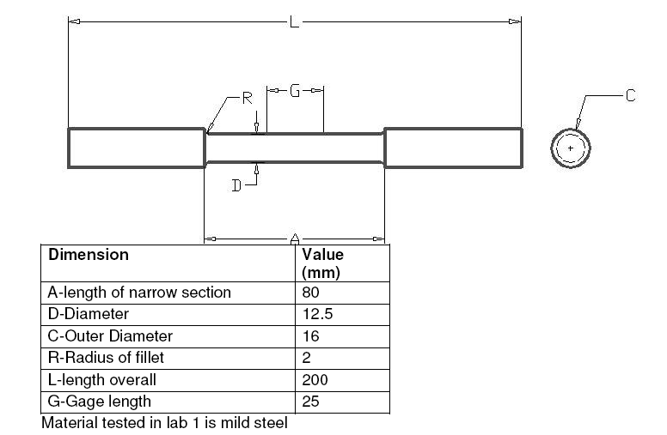

This specimen’s dimensions are for the first experiment of the low carbon steel, in this experiment (experiment 2), we use less diameter in the specimen, since high carbon steel is more brittle than low carbon steel, which implies that it has more yield strength and ultimate strength. This indicates that more loading we must impose on the specimen of same size to that of experiment 1. The role of the smaller diameter specimen comes since the Hounsfield testing machine has a loading limit of 100 KN.

**Experiment 2’s specimen**





The Hounsfield UTM testing machine supplies us with the data of load-strain curve.

1. Analysis and Calculations

***Note: Graphs are included in the appendix section.***

**A0** = (π D2 )/4 = π x (9 x10-3) 2/4 = 6.3617 x 10-5 m2

**L0** = 25mm

The data that we gathered from the experiment is the deformation of the bar and the force that was applied to form that deformation.

To get a stress-strain curve we need to plot stress vs. strain.

**Stress=** load/area = F/ AO = σ

So we find the value of stress for each corresponding force.

**Strain=** deformation/ gage length = δL/LO = ε

where δL is the extension of the bar (in mm) which is given to us

and LO is the gage length.

**Proportional limit stress σPl** =stress value at which the stress-strain curve goes nonlinear

σPl = 618.935 MPa

Compared to the proportional limit stress in the last experiment which was :

σPl = 1068.11 MPa (experiment 1)

The proportional limit stress in experiment 2 must be greater, but since we have a different diameter we can’t really compare this property of the material.

**Yield Point Stress, σY**= stress value at which the stress-strain curve goes horizontal

σY = 1026.84 MPa

Compared to the first experiment where the yield point stress was:

σY = 1058.679 MPa (experiment 1)

we find that the values are close even with the difference of specimen diameter, this somehow indicate that the second specimen has a higher yield point stress if the specimen had the same size.

**0.2%-Offset Yield Stress, σ0.2%Y** = the stress value at which a line drawn with slope E starting at 0.002 strain intersects the stress-strain curve

σ0.2%Y = 1065.748 MPa

When also here comparing to experiment 1’s value, we find the 0.2 offset yield stress is almost the same knowing that the specimen diameter of this experiment is less than that of experiment 1. This shows that the material of specimen 2 is more brittle.

σ0.2%Y = 1065.753 MPa (experiment 1)

which is calculated graphically

**Ultimate Tensile Stress (σult ):** largest stress on the stress-strain curve

Therefore, from graph we can see that **σult = 1085.79 MPA.**

Compared to experiment 1, the ultimate tensile strength in specimen 2 is much greater than that of specimen 1 taking into consideration of the specimen’s difference in diameter.

**σult = 1069.285 MPA. (experiment 1)**

**Fracture Load =** final force applied when specimen fractures or breaks

So for our specimen, from Load-Deflection Graph, fracture load = 66225 N

The fracture load in the last experiment was 61000 N

The material in specimen 2 is more brittle, since despite its smaller diameter, it has a higher fracture load.

**Engineering Fracture Stress**: It’s the stress at fracture point= fracture load/original area = 66225 N/ 6.3617 x10-5 m2 = 1040.995 MPa.

In experiment 2, the engineering fracture stress is more than that of experiment 1 despite the difference in diameter.

stress at fracture point= fracture load/original area = 61000 N/ 6.3617 x10-5 m2 = 958.863 MPa.

**True Stress (σT)** = F/Ai = σ (1+ ε)

True stress values that were calculated from stress values are shown in the Tables (Appendix).

**To find the value of the new area we use the equality**

**Volume1 = Volume2**

**Area1 x L1 = Area2 x L2**

(6.3617 x10-5 m2)(25 mm) = area2(25 mm-3.84mm)

Therefore, area2 = 6.6937 x 10-5 m2 .

This is the uniform area.

**True Fracture Stress** = Ff / Ai : It's the true stress at fracture point= 989.361 MPA.

The true stress at fracture point= 589.853 MPA. (experiment 1)

In experiment 2, the true fracture stress is more than that of experiment 1 despite the difference in diameter.

**True Strain (εT)** = ln (Li/L0)= ln(1+ ε)

True strain values that were calculated from strain values are shown in The Table(Appendix).

From the true strain- true stress equations and using the strain and stress values, we form another curve (true stress-true strain curve).

**Modulus of Resilience** = UR : It represents the area under the elastic portion of the stress-strain curve. Numerically UR= σy2/ 2E = 1026.84 2 / 2 X (1512.4) = 1.064 MPA.

**Modulus of Toughness** =**UT** : It represents the area under the whole stress-strain curve. To calculate it, we use the stress strain curve. We applied a rough approximation where we took the area from the yield stress till fracture as a rectangle. And the triangle of the yield stress perpendicular to the axis axis and starting from the origin.

Area of Triangle = (1026.84 x 0.00275)/2 = 1.412 MPa

Area of Rectangle = (1026.84 x (0.0155-0.00275) = 13.09 MPa

**UT = 1.412 + 13.09 = 14.5 MPa**

**Energy at Yield =** area under the elastic portion of the load-deformation curve.

To Approximate the energy at yield, we calculate the area of the triangle connected by the origin, the yield strength point, and its projection on the x-axis.

Energy at Yield = 65325 N x (0.22 x 10-3)m = 14.3715 J

**Energy at Break =** area under the entire load-deformation curve.

To calculate it, we use the force-deformation curve. We applied a rough approximation where we took the area from the yield stress (force) till fracture as a rectangle. And the triangle of the yield stress perpendicular to the x axis and starting from the origin. Area of Triangle = 65325 N x (0.22 x 10-3)m = 14.3715 J

Area of Rectangle = 65325 N x (1.24 – 0.22) x 10-3 m = 66.6315 J

Energy at Break = 14.3715 + 66.635 = 81.003 J

**Percent Elongation** = ( Lf-Lo)/Lo x 100% = [(23.76-25)/25 ] x (100)= - 4.96 %

**Percent Reduction in Area** = ( Af-Ai)/ Ai x100%=(6.6937 x10-5 -6.3617 x 10-5)/6.3617 x10-5 x100=5.21 %.

Percent elongation (experiment 1) = -9.6 %

Percent reduction in Area (experiment 1) =18.14 %

The comparison between results of specimens 1 and 2 show that specimen 1 is more ductile than specimen 2.

1. Observations

Like the specimen from the previous lab, we were able to notice that the rod has a small groove in it, and the groove is made to assure that the shear in the rod will happen in the middle where the groove is made and not in another location due to manufacturing errors or impurities.

During the process a sound of cracking was heard. This was due to the slippage between the specimen and the machine, in addition to the cracking of the particles of the specimen itself. At some instance, we can notice the deformation (elongation) of the rod, and the changes in the load curve.

As it is the case for all solids, the rod deformed in a relatively small manner, the deformation was slightly noticed, and the necking phenomenon was noticed with careful observation of the whole process.

The rod upon fracture produced a loud sound that similar to that we heard in the first lab.

After the fracture occurred, the specimen at the surface of fracture shows a different aspect than that of a cup and cone that we noticed in the first lab. The fracture showed a

1. Conclusion

If we look at the stress-strain, we would see that a large part of the curve keeps going upward until the bare breaks, and this shows that there was small plastic deformation. If the deformation is not very plastic, then this means that it is brittle. The main differences between the behavior of low carbon and high carbon steel could be summarized in the following table.

The change in area was negligible. The difference between the behavior of high carbon and low carbon steel under the effect of tensile forces can be summarized in this table:

**Low Carbon Steel**  **High Carbon Steel**

|  |  |
| --- | --- |
| Necking is observed preceded by fracture. | Instantaneous fracture is observed. Necking is applicable. |
| After fracture one end was concave and the other was convex. ( The cup and cone phenomena). | Propagation of crack line from a break point. Surface of fracture is flat and rough with the appearance of a shiny and a dark region. |
| Large plastic region after the yield point. | Small plastic parts (insignificant compared with the low carbon steel). |

1. References
2. Wikipedia. *www.wikipedia.org*
3. Dieter, G.E., *Mechanical metallurgy*, 1988, SI metric edition, McGraw-Hill.
4. R.C. Hibbeler, *Fundamental of materials science and engineering, 7th edition*, 2008, SI meteric edition, Prentice Hall.

1. Appendix





